**The Merton Way**



**Sort of……**

**A word from the Chairman**

The season is now underway at last and we have already had two home league games with two more scheduled this Saturday. A mixed bag of results but early days. An important fact is that we have match reports on all the games. Well done guys!!

There are two important matters I need to nag about. Firstly payment of subs and then signing up to SLATE. Then I hope you really enjoy your football and so much more. And there is a lot more. We have got a great bar for ‘Apres Football’ and an ever growing camaraderie within the club. Then come along and support events. The Quiz night (Oct 13th ) is a legendary night of fun. Sign up for a table. Guests are welcome. And then we have the Vets game on October 20th, a race night and Christmas ‘Jump off’.

You will also see information in this newsletter about the ‘Algarve Tour' in May next year. If you are interested please sign up now.

Good Luck to all our teams for the weekend!!

Max Herbert

**2018 Events: SEP – DEC**



**SATURDAY 13th OCT – THAT’S THE MERTON QUIZ**

*(Classic Quiz, Teams of 6, Fish & Chips - £10pp)*



***SATURDAY 20th OCT – VETS v OLD WEST CITZ (VETS GAME)***



**SATURDAY 10th NOV – MERTON RACE NIGHT**

*(TV horse racing / bets / prosecco bar / race-cards / £10pp)*



**SATURDAY 8th DECEMBER – THE MERTON XMAS JUMP OFF**

*(Traditional Christmas Jumper Night, Christmas DO for Merton)*



**Merton Tour: Algarve Portugal**

Merton FC will be touring the Algarve next May. The plan is to take 18 people, with two teams who will compete in an open-age, 7-a-side tournament. The dates will be 9-12 May, 2019.

We have been offered a 3-night package, costing 180 euros per person. This includes:

* Accommodation at a 4-star hotel in central Albufeira. Exact hotel is TBC, but all are in great locations near bars & restaurants & 10 minutes’ walk to the beach (between Old Town Albufeira & the Strip)
* Private Airport transfers on arrival & departure. They will meet us at the airport & be on hand at the hotel to assist with the check in to make this quick and easy
* Entry to the Algarve Football Tours 7's Cup for two teams (with match officials, complementary water, trophy presentation). Transport to and from pitches from hotel

Flights are not included in the package. These are expected to be in the region of 180 to 200 quid.

At this stage, we require an expression of interest, and we will soon request an initial deposit to confirm your place. Please get in touch with Clappers, Toddy or Max to express interest, or if you have any questions.

**Slate and Membership fees**

There are still a number of players who have not yet paid their membership fees. Please sort this out ASAP. You can pay via bank transfer, Slate, at the Bar, or even cash.

Following the AGM, it has been agreed that fees for the year will be as follows:

Adult members - £90

Refer a Friend - £50 each

Under 21s - £30 each (21 or under when the season starts)

Social members - £20

The good news is that match fees will remain at £10 (£5 for U21s). And, as ever, some of the most competitive bar prices you could ever wish for.

**Slate**

To make things even easier for you – both in terms of membership fees and match fees – you can now pay either/both via a click of a button through the new Slate app.

If you haven’t done so already, head to https://app.slateapp.co.uk or download the app. Click on register and use the email address you supplied Merton FC when you joined. Once registered you will receive an ‘activate your account’ email (check spam) and follow the instructions in the email.

After you have activated your account you will receive another email asking you to set up payments for your Slate account. Follow the instructions in the email to do this.

Any questions, then please get in contact with Darren Avey.

**Last Man Standing**

Signing for Slate will also enable you to get involved with our new Last Man Standing game – one which has already proved very popular with the 30-odd members who have signed up. In short, it’s a really fun predictor game whereby you pick an EPL team to win each week - https://itunes.apple.com/gb/app/tippd-last-man-standing/id1185126669?mt=8). It’s a £5 entry fee with 70% of the pot going to the winner and 30% of the pot going to the club. We use an app for this game so you make your picks through that.

Be sure to get involved when the next game starts - you will need to pay through the app, bank transfer or give cash to a responsible party, after which we (as in Darren Avey) will share the invite codes.

**1s Match Report**

**Merton 1-2 EBOG**

Please excuse the brevity of this report but I’m having to write it in a hurry as our DOTD, Siri, hasn’t done it. Further cementing his DOTD status.

A long trip to High Barnet, it never gets any closer, was made longer for Siri, Jimbo and Harrison because Siri had left his football boots at work. Why wouldn’t you leave your boots at work on a Friday? DOTD was written in the stars.

The slope on the pitch at EBOG tends to dictate tactics a bit and when it’s rock hard and windy those tactics tend to get confirmed. Play over and around whichever poor sod is full back up the slope and work from there.

After an even first half we went in 0-0 and were pretty please. In fact we were very please having lost 11-0 the week before and given EBOG were relegated from Div 1 last season.

The second half started well but then we conspired to gift EBOG two goals. One down the right, after Ciaran (Dennis Irwin) stepped on the ball, and there full back crossed for the forward to get in front of an uncharacteristically slow Browner.

The second goal confirmed our man Siri’s DOTD vote as he miss hit his goal kick along the floor straight to their centre forward who turned and smashed it back over his head from 30 yards. Siri explained he didn’t jump for it because he knew he was beaten. We are still wondering why he didn’t jump for it!!

EBOG then had a man sent off for a head butt. A silly thing to do as he was their best player but also because it was into Browner’s shoulder. Sadly they coped with 10 men better and we didn’t have the wit to break them down.

We got our consolation goal with a minute to go. A great corner from Jimbo, lucky as the one before was dreadful, and a good header from DQ.

A draw would’ve been fair but life’s not fair.

Siri, Joe Grew, Harrison, Clappers, Browner, Jimbo, Pritch, Akram, Tom Rowe, DQ, George. Sub: Ciaran

Scorer DQ, assist Jimbo.

MOTM: Joe Grew

DOTD: Siri

**2s Match Report**

**Merton 2-2 HSBC**

Debuts for Jack Costello and Craig Bull (no, not that one – a considerable upgrade on the previous Merton man of the same name), the return of Gibbo after his London Marathon 15km and the reincarnation of Cookie were among the headlines for Team Handsome’s first league game of the season – away at HSBC.

That’s to take nothing away from Sam Singer-Ripley in goal, who saved his side more than once against an HSBC team with pace and no small intent. It was largely thanks to Sam’s heroics and savvy keeping that Merton came in at half-time two goals to the good.

Those goals, then: both intricate passing moves set in motion by the bravery, quick thinking and application of Merton’s defence and tireless midfield, epitomised by Cookie. Both moved from right to left, with Robert’s strength and quick feet buying him time and space to pick a pass. For the first, the ball found its way to Cookie, whose looped through ball bounced invitingly in front of Ackers. Our man was still at an acute angle, but his first-time (left foot!) half-volley was too much for the goalkeeper – who could only take a moment to admire the ball nestling in the opposite corner of his net. It was a passing move of awesome quality that got the finish it deserved.

Merton’s second was arguably better. Pearcey nicked the ball off his opponent’s foot and set us away. Robert–Cookie–Dan Rist, whose precise pass to Craig Bull gave Merton 2s’ new right-back-turned-left-back the space to cut in and fire the ball under the despairing keeper.

Honourable mentions go to Robert, who had obviously spent the first 20 minutes on the bench working out exactly how he was going to dismantle HSBC’s left side, and EJ, who were a constant menace. Ackers was superb as our lone striker – though at least this week he received plenty of support. Gibbo easily ran further than he did at the London Marathon (perhaps his local newspaper will interview him about this). We have missed his presence. Risty’s use of the ball was, as always, top-drawer.

Haydn and Jack at the centre of our defence were in a no-man-shalt-pass sort of mood; they were dominant in the air, brave and brilliant throughout. Wilgo, filling in at left-back after Craig found himself too tired to pass, had to help them out only the once – throwing himself across the box in the final minute of the game to stop what would likely have been a hugely dispiriting winner for HSBC. Merton had earned this.

The final word should go to the Man Most Handsome: not only did Cookie avoid being booked or sent off for 90 minutes, but his industry and quality was at the heart of everything Merton did. Ben, where have you been?

Goals: Ackers, Craig Bull

TEAM: Sam Singer-Ripley (GK) Craig Bull, Jack Costello, Haydn Dance, Paul Pearce, Dan Rist, Ben Cook, Gibbo, Wilgo (c), EJ, Ackers; Robert

**3s Match report**

**Merton 1-3 Polytechnic**

With the return of Mustard to the Whatsapp group and the introduction of the newbies to the group rules, Merton 4's were getting ready for some action away against Polytechnic.

A quick team talk by Iain before the start of the match gave the boars confidence to try and win the match.

The game started a bit slow with possession of the ball from both sides, however, Poly managed to complete more passes than us mainly playing on the left side with their winger and fullback joining the attack, producing a few instances that could have ended up in a goal. Luckily we had MOM Ryan playing left back and displaying some good and timed tackles that managed to keep the opposition from scoring and creating chances.

Our keeper also did put some good saves in the first half which enabled the team to try and counter attack. There was only one real chance for us in the first half to convert from a through pass from the middle of the park into the box which our striker (not sure of his name - Sam maybe?) didn't manage to convert.

No changes made for the second half and after just under ten minutes Poly managed to score, 1-0 for the opposition and already under a lot of pressure. After a foul throw from Mustard, I think he decided he had enough (of his injury appearing again of course), and asked to come off.

I'm not sure how or why but our keeper suddenly struggled to kick the ball from his own area, unfortunately, this cost us a second goal from Poly as the ball did just manage to go over the penalty area. That was it 2-0 down.

I (Ricky) was increasingly frustrated with the referee decisions as no offsides were called off, allowing the opposition to play on few clear offsides occasions.

Even more when we were unable to complete good passes, or simply holding the ball, and yes I'm talking about you Billy!

When I thought that we were going to get one back as Neal put a lob pass over the defense, Poly's last man handled the ball inside the box and the referee blows the whistle and to my surprise, it was for a foul from me apparently. No way, this ref is blind I thought and shouted.

The opposition managed to score after that again and I managed to get sin-binned and consequently DOD.

On the last few minutes, Merton carried on with ten men and somehow Willy (as he was going to post on Facebook) score with a decent finish. Final result 3-1 to Poly.

In every end, there is also a beginning. Let's begin a good season on our next game and stay positive.

MOM - Ryan Burchell

DOD - Ricky

**4s Match Report**

**Merton 4s 3 – 3 Polytechnic 6s**

The first game of the 2018/19 season say Merton 4s host Polytechnic 6s. With squads yet to be settled following an exodus 4th team regulars from last season, there were more new faces than old with only myself, Kieran Lee, John Gridley and Dom Plumridge surviving.

The first half was one of few chances for Merton however for the visitors, the hit the bar and had a ball cleared off the line courtesy of Matt Nightingale. For an individual of his stature, it was probably the best goal line clearance I have witness during my 14 years at Merton. 0 – 0 at the break.

Where the first half was a period that was easy to forget, the second was one full of action. Following a push in the back, Polytechnic were awarded a free-kick from about 25 yards out. From the resulting set piece we found ourselves a goal down when a composed header found the back of the net. 1-0.

1-0 soon became 2-0 when a spot kick was harshly awarded. John Gridley unable to move his arm out of the way in time when the ball was ‘pelted’ at him from 2 yards all. Regardless of the appeals, the penalty stood and was converted into the bottom right hand corner of the net.

For a team that had not played together before, not even in pre-season, everyone was grafting and working for each other. This was evident when Dom managed to pull a goal back. Merton were back in the game!This however was short lived! Less than 5 minutes from the restart, the visitors managed to restore their 2-goal advantage through a goal reminiscent the Luke Shaw/Marcus Rashford linkup against Spain a few hours later.

Disappointment was showing having worked so hard to get back into the game however we continued to press and was creating chances. Finally, one of these paid off. Denys delivered a delicate ball into the box which Dom again managed to latch onto to reduce the deficit once again.

With less than 5 minutes to go, it was gung-ho. With every offensive opportunity we committed men forward, never giving up. Our resilience was rewarded. A free-kick was award to Merton just inside the oppositions half. With Andy Bitmead on the ball and Kieran Lee in the mix, Andy’s delivery was cleared however only as far as John Gridley on the edge of box. His ball back in could only be parried by the keeper which allowed Jonas Cabrera to unleash a right footed volley (might have been half-volley!) into an empty net. Jubilations!

This was a draw which felt more like a win! Each and every player gave it their all and I couldn’t have asked for anything more. We keep up this hunger, who know what we could achieve this season.

Next week would have seen us travel to Chiswick to face off against IBIS Eagles however this match has been postponed and will be rescheduled at a later date.

**SCORER(S):** Dom Plumridge (2) and Jonas Cabrera **MOTM:** Chris Outred – A solid performance having been called up from the 5s.

**DOTD:** Kieran Lee – A sliced clearance that could have been VERY embarrassing had he not recovered.

**5s Match Report**

**Merton 5s 2 – 0 West Wickham 6s**

This Saturday marked the 5s first game in Division 4 having ran an extraordinary promotion campaign last term that saw us finish 7th but still get promoted; a feat only eclipsed by Poly 8s finishing bottom of the league but still getting promoted 2 years ago. Pre-match preparations were nothing short of shambolic. First, the kit was still at the Kimbers with no one home. Luckily we used the Merton time machine to go back to the 60s [a decade which Steve B remembers well] to find one that sort of resembled our traditional colours, so problem solved. Also the Council with their usual efficiency forgot to put the nets up, meaning that we had to do it ourselves. Seeing our shambles, the opposition matched it by having one player turn up 15 minutes late [which we sportingly delayed the kick off for] and 2 not showing at all, meaning that they were playing with 10 men.

They started with more possession despite being a man down, which was a regular feature throughout the match, however it was mostly across the backline/defensive midfielders and once we pressed, they had to go direct which our defence dealt with easily. We hit them on fast, sharp counters and had some moves of great promise. The first was a great ball through to Dulanjie who was running on to it past a static defence. Arms were raised and the referee blew for a dubious offside – much to our annoyance. They did not heed the warning though and minutes later, the same thing happened again. Andrew ran on to the ball in the centre of the pitch and played a lovely waited through ball to Dulanjie. Consensus seems to suggest that we thought he actually was offside this time, but this time the whistle didn’t go. 1 on 1 with the keeper, D calmly slotted it home to put us 1-0 ahead. The second followed not long after, with D instrumental once again. He unleashed a powerful shot from 20 yards which the keeper did well to parry wide. The ball came back in the box and some good movement from Phil saw him get in front of the keeper and chip the ball over him. With a defender on the line, Phil fired high into the net above the despairing goalkeeper to make it 2-0.

The lead was entirely deserved. Lenners in goal had nothing to do apart from come out and punch the ball away from a couple of corners, doing so in such a way that you can tell it’s not the first time he’s punched something. The only thing that mired the half was a little bit of moaning, epitomised by Tiggy throwing a strange tantrum over Tom wanting to take a throw in. All was, however, forgiven and we knew if we kept it as tight as that in the second half, we would win the game.

They put us under some pressure at the start of the second half, manufacturing a couple of half chances. A good ball from deep caught us out a little, however their player at the back post was stretching and headed wide. They also had their first [and last] shot on target when their midfielder broke lines to run onto a through ball. 1 on 1 from a wide angle, Lenners closed him down well and palmed the ball wide of the post to pull off a very good stop. Other than that, we were comfortable and had some great chances to seal victory. D’s cross went a little wayward, almost catching the goalkeeper out at the near post. A pullback with D and Yaw in the box just lacked a little quality, otherwise they would have had an easy tap in. The highlight though was a mazey run by Tom who picked the ball up from about 40 yards and just ran. He beat 2 or 3 players and the space opened up on the 18-yard box. He dragged just wide, however it was a great individual effort. We lacked a little bit of incision in the final ball with the game stretched, possibly a little more than we would have liked it to be as quite a few players were going forward quicker than they were getting back. All in all, it was a great performance and a fair result to kick off the second chapter of our quest for two promotions in a row.

There were a few contenders for man of the match. Lenners did everything he needed to well, the back four were solid throughout with Tom, Darren, Scott and Lyndon all getting the best of their attacking players. Our midfield dominated and pressed very well with Tiago holding, Andrew getting on the ball well and keeping the team ticking, contributing a very good assist, and Sam’s pace causing a problem for their defence with Steve coming on and adding some much-needed energy in the second half. Phil and Dulanjie were dynamic in attacking positions and caused the opposition all kinds of problems, with both getting vital goals, and Yaw coming on in an attacking role looked a threat. Man of the match was close between Scott and Tom, however Scott edged it in his first competitive game for Merton in what was a fine performance.

MOTD Scott Brown

DOTD Tiago Carvalho

Goals: Dulanie Richards (Assisted by Andrew Stears) & Phil Truman (Assisted by Luke Newman)

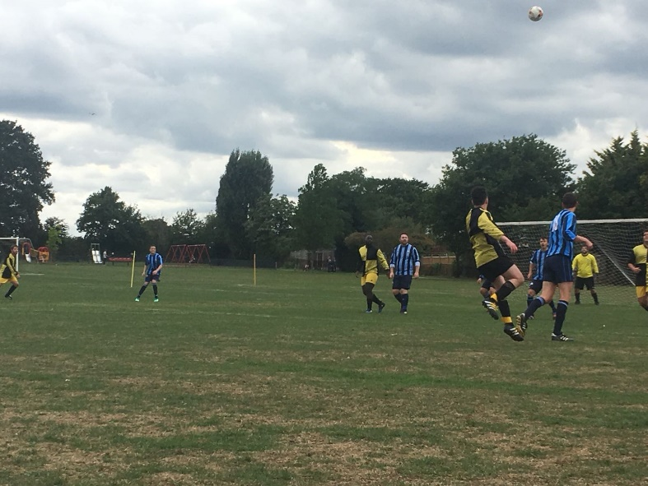

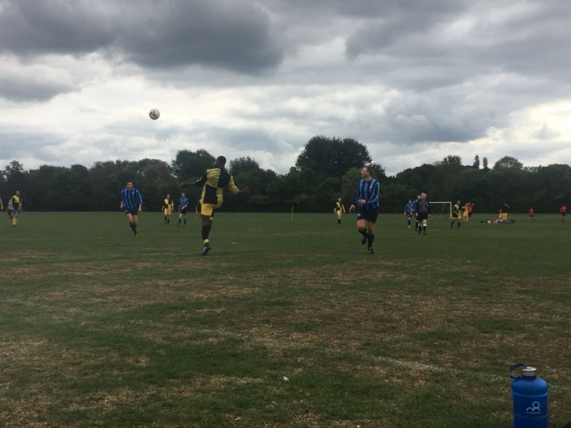

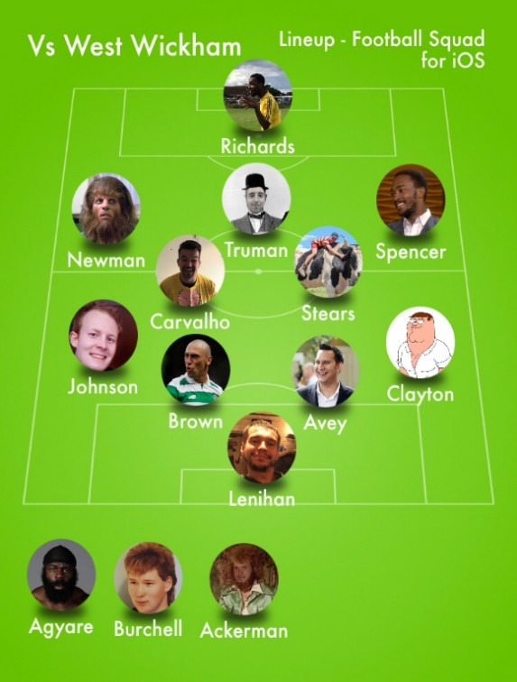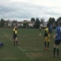

**6s Match Report**

**NO GAME**

**Merton FC Fixtures – 15/09/2018**

|  |  |  |
| --- | --- | --- |
| **Team** | **Opposition** | **Venue** |
| 1s | HSBC | Home |
| 2s | Weirside Rangers | Away |
| 3s | Reigatians | Home |
| 4s | NO GAME | N/A |
| 5s | Polytechnic | Away |
| 6s | City of London | Away |